# Scratch logo and symbol, meaning, history, PNG

**Scratch Invaders 4**

Register/login at <https://scratch.mit.edu>

*Defensive shields – Shields take damage from the invader’s bombs. This is hard to create with sprites,   
so use pen graphics to achieve this effect.*

1. Add the Pen extension
2. Download *invader* images from:  
   <https://codeclub67.github.io/images/invader.gif>
3. Create a new **shield** sprite from the *invader* images, and select the shield costume.

*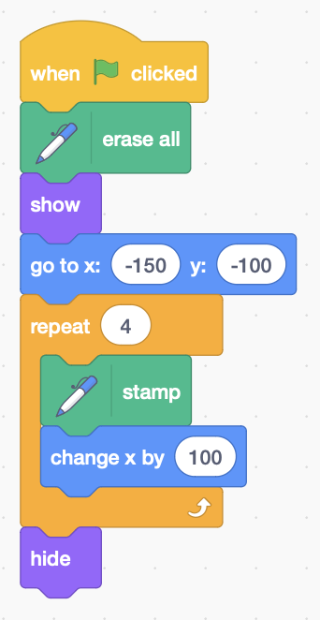So that you can draw over the shields, stamp them onto the screen with the pen.*

1. Add code to the **shield** that **stamps** four shields near the bottom of the screen, 100 pixels apart, then hides the original sprite.

*Make the existing missiles and bombs interact with the shields. You need to detect the shield colour rather than the sprite itself.*

*Run your code so that you can see the shields on-screen.*

1. 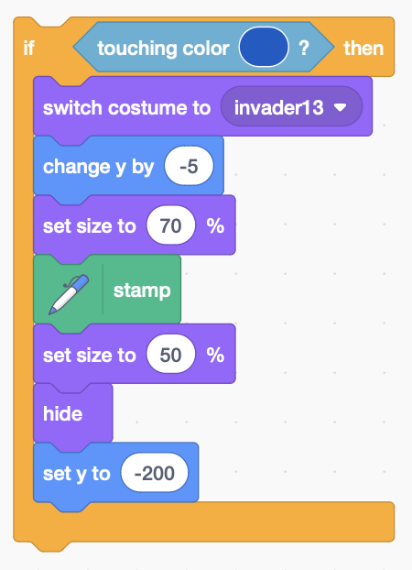Add code to the alien bomb to detect when it’s **touching** the missile colour. Add this inside the repeat loop that makes the bomb drop.
2. To get an exact colour match, click on the colour swatch in the **touching** **colour** block. Select the colour picker at the bottom of the pop-up, and use it to get the exact shield colour.
3. **Switch to costume** invader13, a black hole **stamped** on top of the shield. It merges with the black background.
4. When the bomb hits the shield, move it down slightly (**change** **y**), and make it slightly larger (70%) to take a bigger chunk out of the shield.
5. 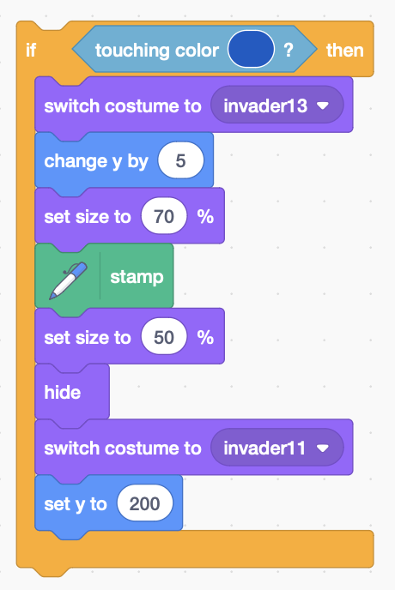Add similar code to the **missile** that shoots upwards and can hit the shields from below. Add this inside the main loop that makes the missile rise.
6. Remember to move the impact point slightly up this time.
7. Switch back to the missile costume, and move it to the edge to exit the loop.

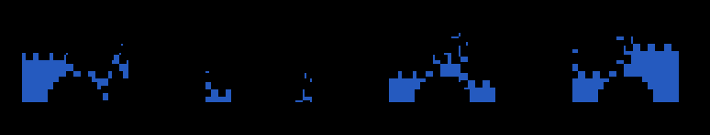

***Save*** *your code.*